Robert Skelton

11.5.12

MATLAB Project 3

x(t)=P (t)

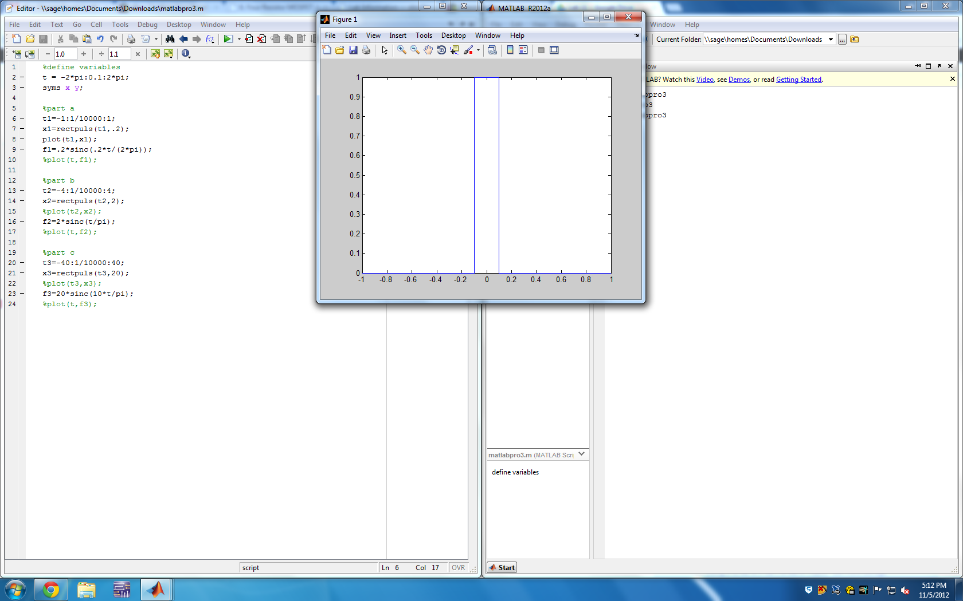

x(t)=P (t)

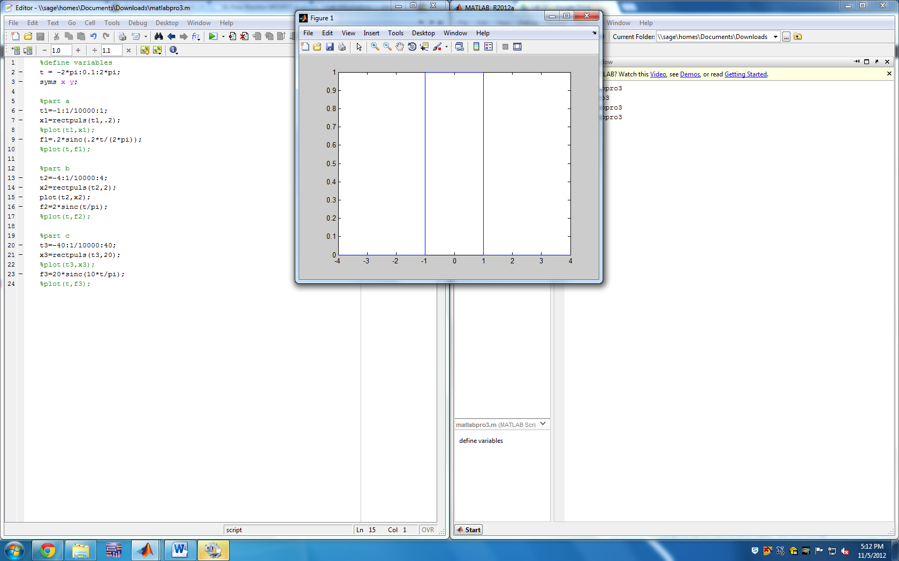

x(t)=P (t)

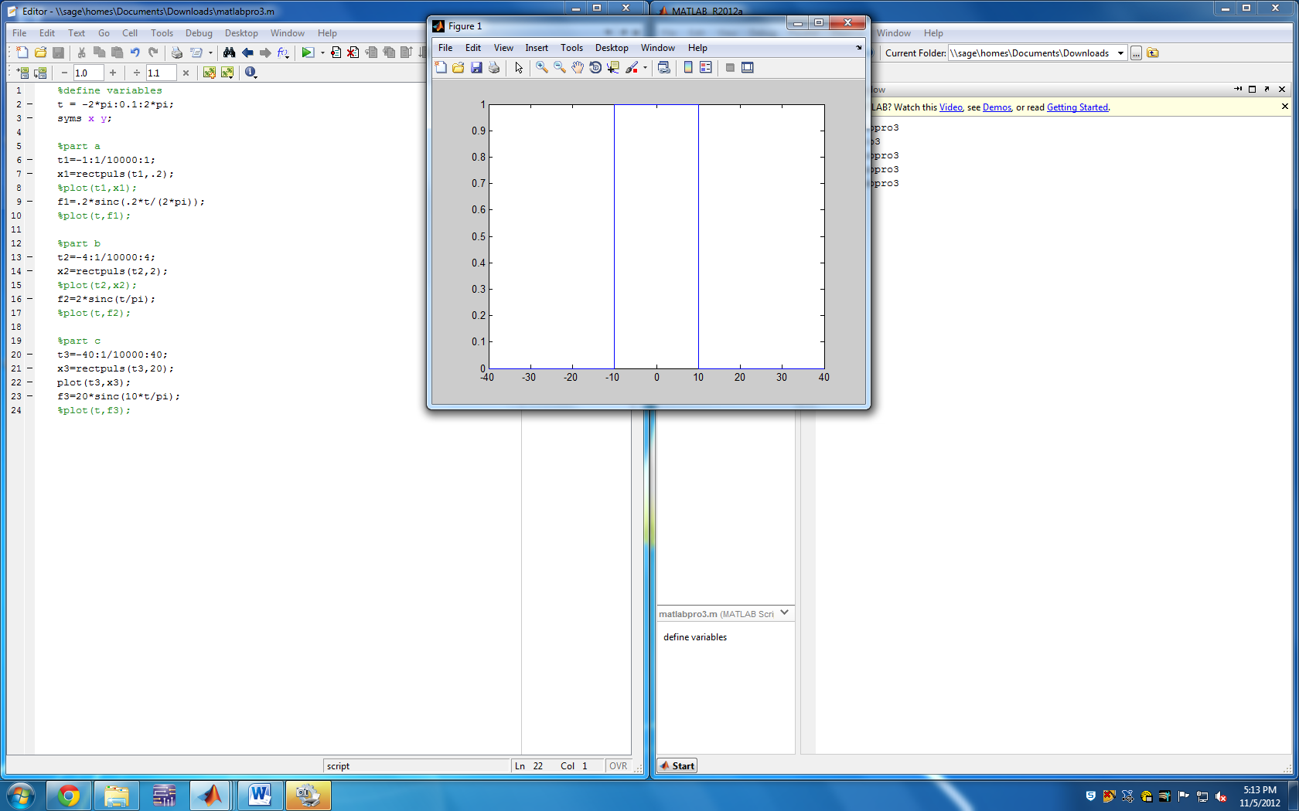

X(w)=.2sinc(w/10pi)

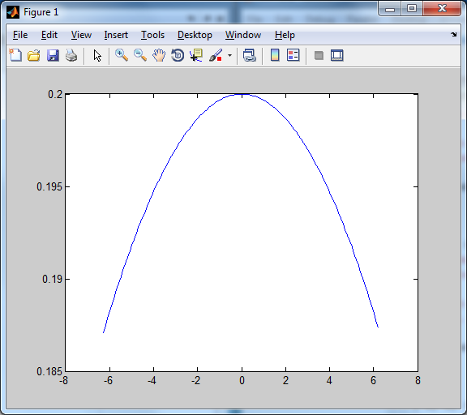

X(w)=2sinc(w/pi)

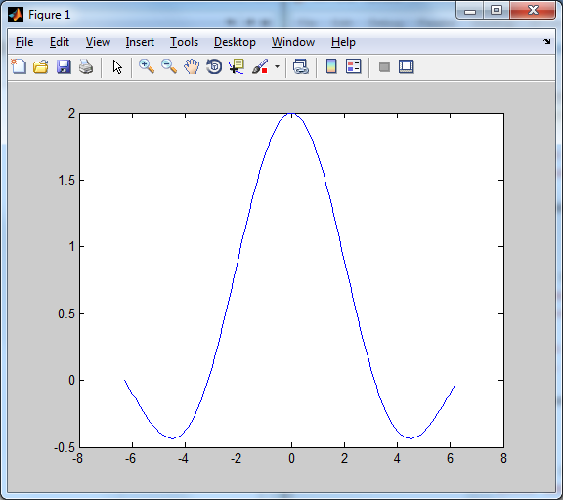

X(w)=20sinc(10w/pi)

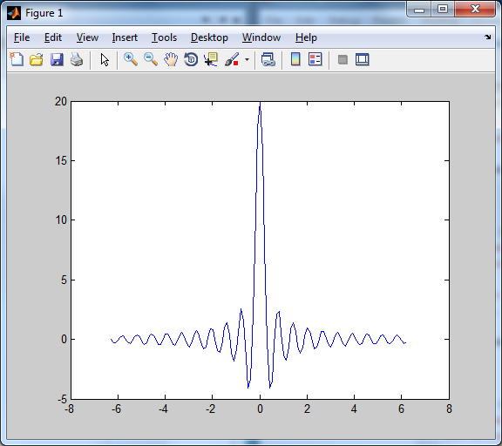

Code:

